**Uber Data Analysis**

Uber is finding you better ways to move, work, and succeed in India.

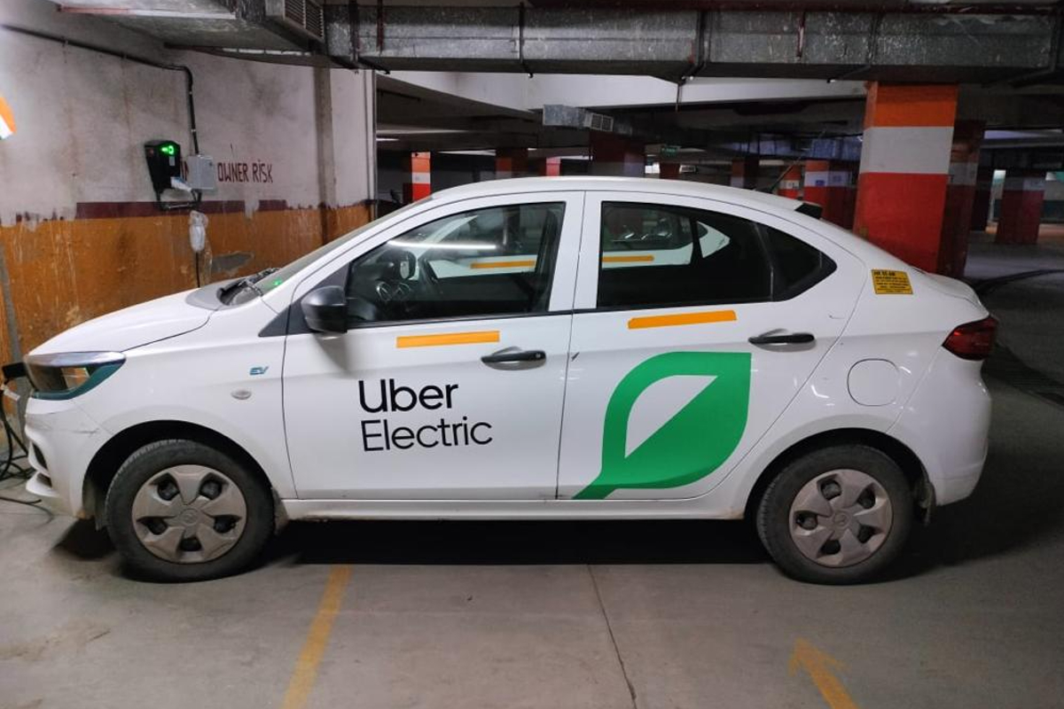

**About Dataset**

**Uber** is a multinational transportation network company that operates a platform connecting riders with drivers through a mobile app. It was founded in 2009 and has since become one of the most well-known examples of a ride-hailing service. Uber allows users to request a ride from their current location to a desired destination using their smartphone. The app matches the user with an available driver in the area, and the driver arrives to pick up the passenger.

Uber offers various types of services, including UberX (standard car), UberXL (larger vehicles), UberBlack (luxury vehicles), and UberPOOL (shared rides with other passengers traveling in the same direction). The fares for rides are calculated based on factors such as distance traveled, time spent on the trip, and demand at the time of the request.

Uber has gained popularity for its convenience, ease of use, and competitive pricing compared to traditional taxi services. It has expanded its operations to numerous cities around the world and has also introduced other services like food delivery (Uber Eats) and package delivery